Student Name ______________________________________ Section ___ Date _________

#### Installing Android Studio

The following steps will guide you the installation of Android Studio.

**STEP 1 Visit the Android Studio Web Site for your download**

Open the following URL on your Web browser.

<https://developer.android.com/studio/index.html>

Click on the download link as shown below for your respective OS



Accept the EULA agreement to start your download bundle.

Click the Save File button on the pop up window to save the file to your designated download folder.

**STEP 2 Installing your bundle**

1. Double-click your downloaded executable (.exe file) to start the install wizard.
2. Make sure to choose all components in your set up including the SDK and Virtual Device as shown below.

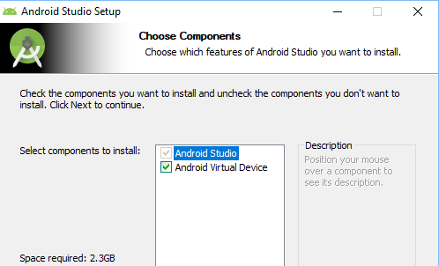

1. Choose the default locations for your install or an alternative path if you desire.

It doesn’t hurt to make a note of the name and location in which it saves the SDK on your system—you may need to refer to the SDK directory later, when using the SDK tools from the command line, loading plugins, etc.

Click Next > to continue the Android Studio Setup. Then Install to complete your setup. When complete you may choose to Start Android Studio (AS) or exit out for now.

**For more information please reference the following sites:**

[**http://developer.android.com/sdk/index.html**](http://developer.android.com/sdk/index.html)

[**https://developer.android.com/about/versions/pie/**](https://developer.android.com/about/versions/pie/)

[**https://developer.android.com/studio/intro/**](https://developer.android.com/studio/intro/)

[**https://developer.android.com/docs/**](https://developer.android.com/docs/)